UNITED STATES

SECURITIES AND EXCHANGE COMMISSION

WASHINGTON, D.C. 20549

_____________

FORM 8-K

______________

CURRENT REPORT PURSUANT TO SECTION 13 OR 15(d) OF THE SECURITIES EXCHANGE ACT OF 1934

Date of Report (Date of earliest event reported) June 12, 2026

ARMOUR Residential REIT, Inc.

(Exact Name of Registrant as Specified in Its Charter)

Maryland | 001-34766 | 26-1908763
(State or Other Jurisdiction | (Commission File Number) | (I.R.S. Employer Identification No.)
of Incorporation)
3001 Ocean Drive, Suite 201
Vero Beach, Florida |  | 32963
(Address of Principal Executive Offices) |  | (Zip Code)

(772) 617-4340

(Registrant’s Telephone Number, Including Area Code)

n/a

(Former Name or Former Address, if Changed Since Last Report)

Check the appropriate box below if the Form 8-K filing is intended to simultaneously satisfy the filing obligation of the registrant under any of the following provisions (see General Instruction A.2. below):

- Written communications pursuant to Rule 425 under the Securities Act (17 CFR 230.425)

- Soliciting material pursuant to Rule 14a-12 under the Exchange Act (17 CFR 240.14a-12)

- Pre-commencement communications pursuant to Rule 14d-2(b) under the Exchange Act (17 CFR 240.14d-2(b))

- Pre-commencement communications pursuant to Rule 13e-4(c) under the Exchange Act (17 CFR 240.13e-4(c))

Securities registered pursuant to Section 12(b) of the Act:
Title of Each Class |  | Trading symbols |  | Name of Exchange on which registered
Preferred Stock, 7.00% Series C Cumulative Redeemable |  | ARR-PRC |  | New York Stock Exchange
Common Stock, $0.001 par value |  | ARR |  | New York Stock Exchange

Indicate by check mark whether the registrant is an emerging growth company as defined in Rule 405 of the Securities Act of 1933 (§230.405 of this chapter) or Rule 12b-2 of the Securities Exchange Act of 1934 (§240.12b-2 of this chapter).

Emerging growth company ☐

If an emerging growth company, indicate by a check mark if the registrant has elected not to use the extended transition period for complying with any new or revised financial accounting standards provided pursuant to Section 13(a) of the Exchange Act ☐

Item 7.01. Regulation FD Disclosure.

On June 12, 2026, ARMOUR Residential REIT, Inc. (“ARMOUR”) produced for distribution a presentation, which contains updates on ARMOUR's financial position, business and operations. Attached as Exhibit 99.1 to this report is the presentation produced by ARMOUR.

The presentation attached to this report as Exhibit 99.1 is furnished pursuant to this Item 7.01 and shall not be deemed filed in this or any other filing of ARMOUR under the Securities Exchange Act of 1934, as amended, unless expressly incorporated by specific reference in any such filing.

Item 9.01. Financial Statements and Exhibits.

(d) Exhibits

 | Exhibit No. |  | Description
 | 99.1 |  | Presentation dated June 12, 2026
104 |  |  | Cover Page Interactive Data File (embedded within the Inline XBRL document)

SIGNATURES

Pursuant to the requirements of the Securities Exchange Act of 1934, the Registrant has duly caused this report to be signed on its behalf by the undersigned hereunto duly authorized.

Dated: June 12, 2026

ARMOUR RESIDENTIAL REIT, INC.

By: /s/ Gordon M. Harper

Name: Gordon M. Harper

Title: Chief Financial Officer

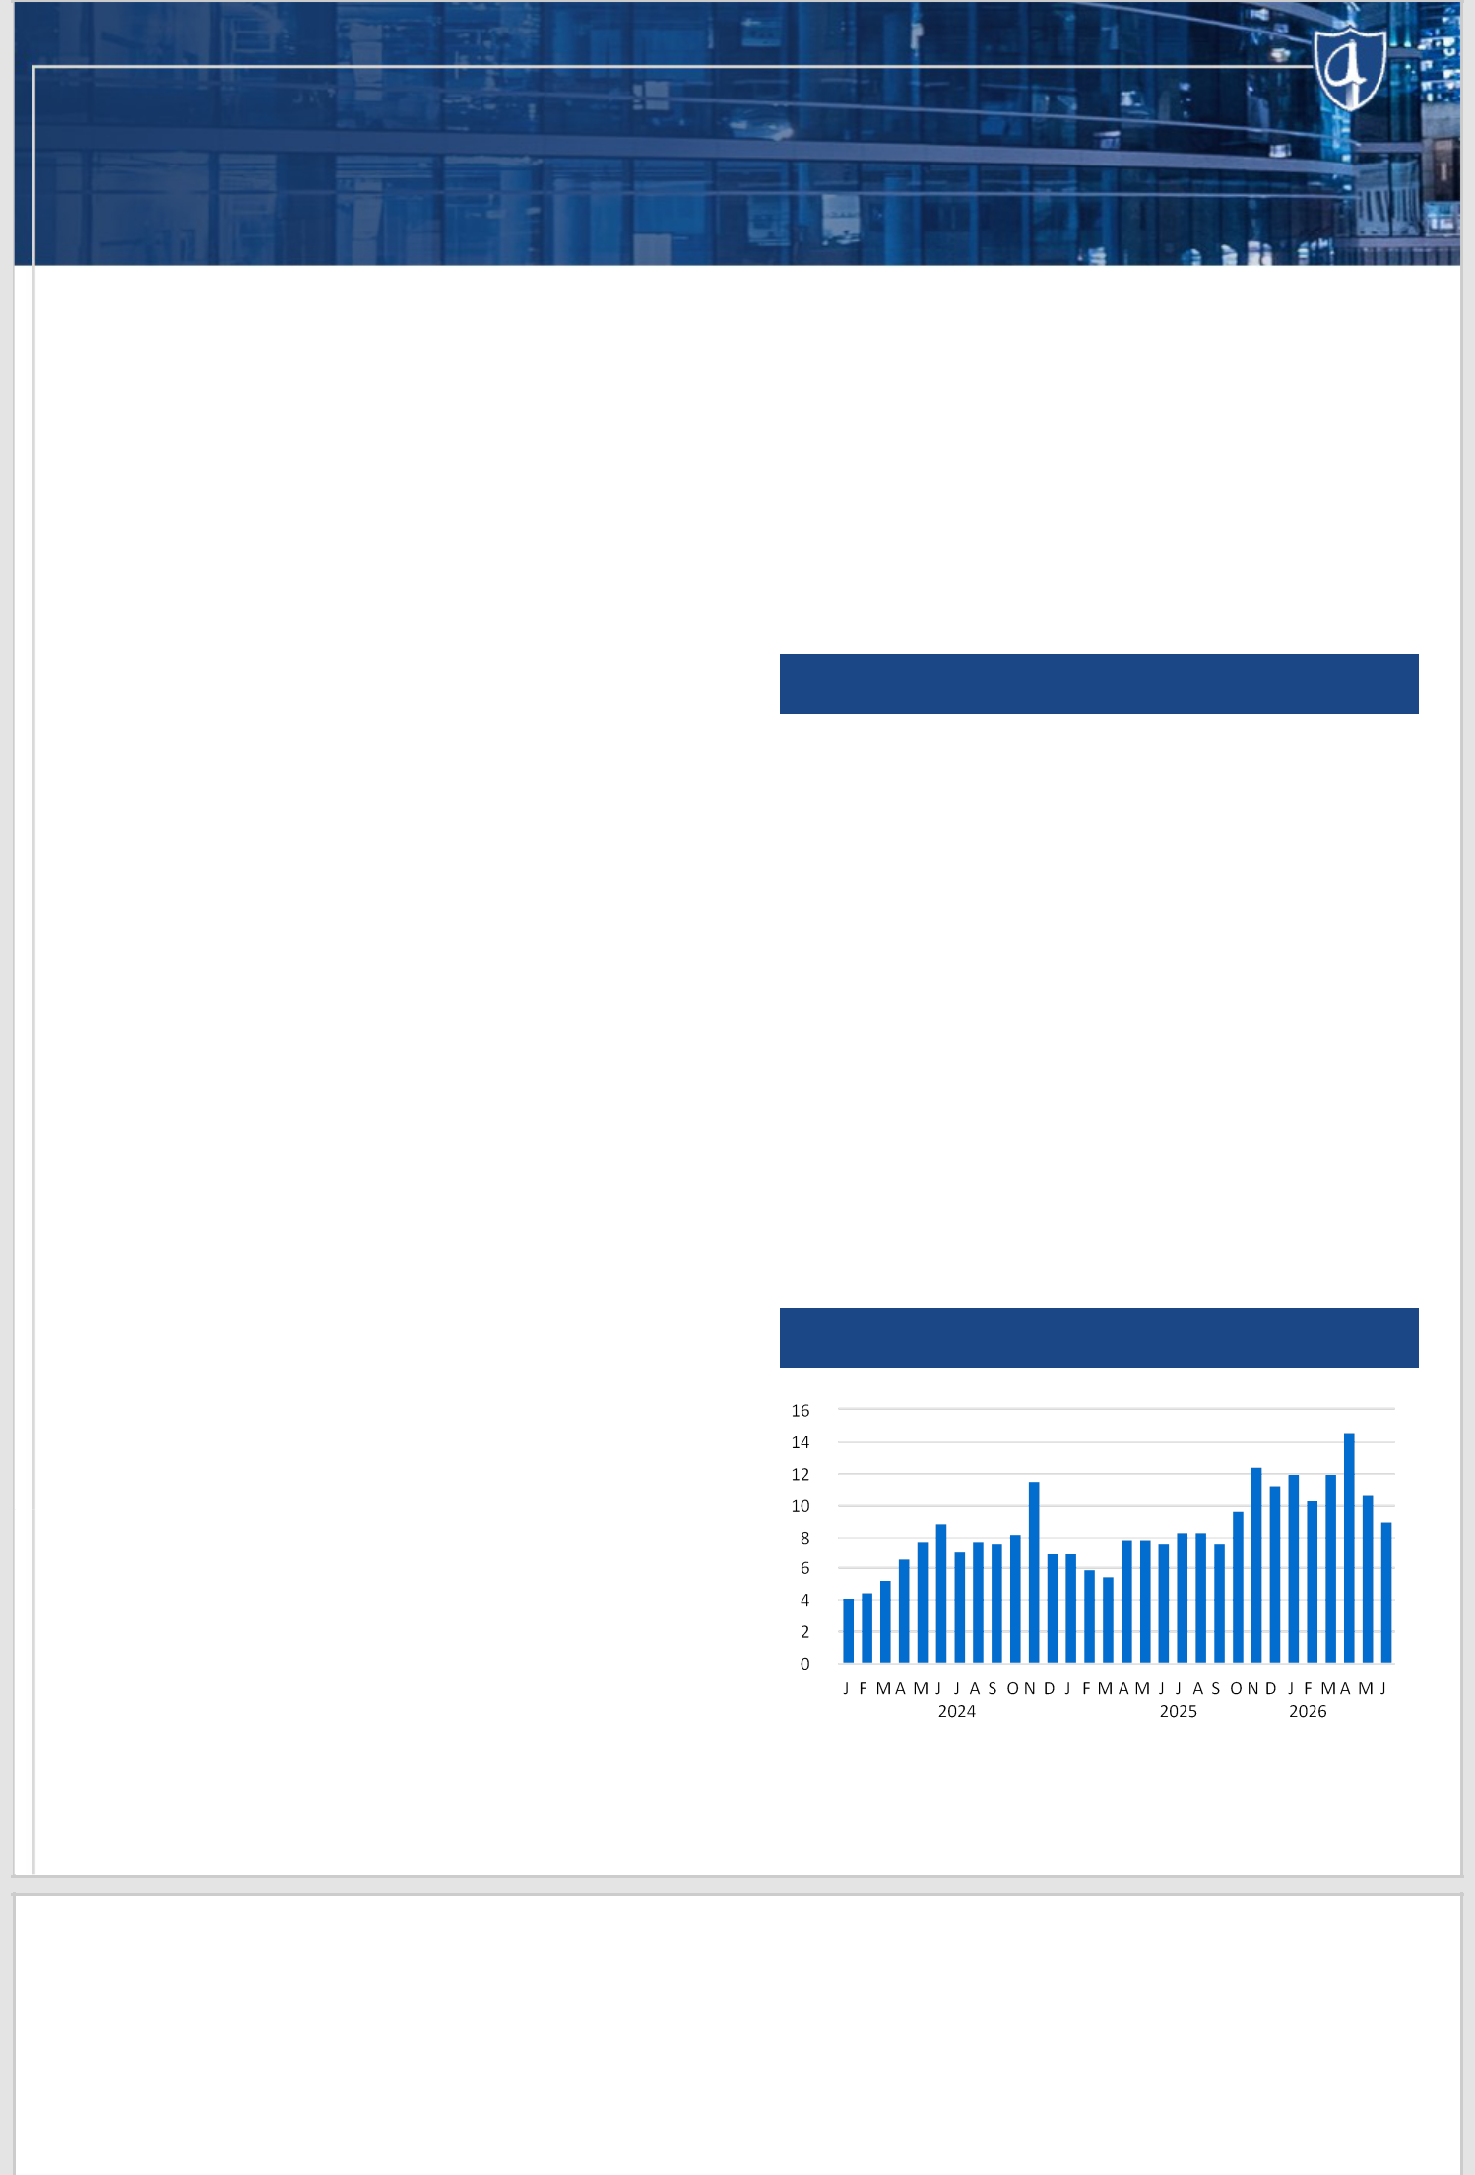
ARMOUR Residential REIT, Inc.

Monthly Update June 2026

ARMOUR Residential REIT, Inc. (“ARMOUR”; NYSE: ARR) brings private capital into the mortgage markets to support home ownership for a broad and diverse spectrum of homeowners. We seek to create shareholder value through thoughtful investment and risk management of a leveraged and diversified portfolio of mortgage-backed securities issued or guaranteed by U.S Government-sponsored entities. We rely on the decades of experience of our management team for (i) MBS securities portfolio analysis and selection, (ii) access to equity capital and repurchase financing at potentially attractive rates and terms, and (iii) hedging and liquidity strategies to moderate interest rate and MBS price risk. We prioritize maintaining common share dividends appropriate for the intermediate term rather than focusing on short-term market fluctuations.

ARMOUR is externally managed by ARMOUR Capital Management LP, an SEC registered investment advisor, which is under common control with BUCKLER Securities LLC, an SEC registered broker-dealer and a member of FICC and FINRA. BUCKLER Securities, LLC, is the largest provider of repurchase financing to ARMOUR. ARMOUR owns a 10.8% equity interest in BUCKLER Securities LLC.

ARMOUR Portfolio | % of | Market | Effective
ARMOUR Portfolio | % of | Value (in $ | Effective
Composition | Portfolio | Value (in $ | Duration
Composition | Portfolio | millions) | Duration
Agency CMBS | 5.9 % | 1,302 | 5.87
30 Year Fixed Rate Pools | 87.9 % | 19,516 | 4.23
Conventionals | 85.5 % | 18,969 | 4.23
30y 2.0s | 1.1 % | 253 | 7.51
30y 2.5s | 1.0 % | 228 | 7.76
30y 3.0s | 3.0 % | 669 | 7.33
30y 3.5s | 4.8 % | 1,069 | 6.58
30y 4.0s | 4.3 % | 964 | 5.87
30y 4.5s | 8.6 % | 1,916 | 5.66
30y 5.0s | 18.6 % | 4,140 | 4.79
30y 5.5s | 25.6 % | 5,686 | 3.45
30y 6.0s | 16.2 % | 3,597 | 2.28
30y 6.5s | 2.0 % | 448 | 1.30
Ginnie Mae | 2.5 % | 547 | 4.09
30y 5.0s | 0.8 % | 176 | 5.57
30y 5.5s | 1.7 % | 371 | 3.39
Agency Portfolio | 93.8 % | 20,818
FN 15y 4.5s TBAs | 0.9 % | 198 | 3.80
FN 30y 5.5 TBAs | 0.9 % | 201 | 3.60
Net TBA Positions | 1.8 % | 399
5Y US Treasury Longs | 4.4 % | 982 | 4.10
US Treasury Long Positions | 4.4 % | 982
Total Portfolio | 100.0 % | 22,198

ARMOUR Key Data

Common Stock Price ($) | 17.15
Debt-Equity ⁽¹⁾ | 7.9
Implied Leverage ⁽²⁾ | 8.0
Liquidity ⁽³⁾ (in millions) | 1,161.9
Liquidity as Percentage of Total Capital | 46 %
Q1 2026 Market Cap (in millions) | 2,062.1
Dividend Information
June 2026 Common Dividend | 0.24
Common Ex-Dividend Date/Record Date | 6/15/2026
Pay Date | 6/29/2026
Current Dividend Yield | 16.8 %

ARMOUR Portfolio CPR

Portfolio and Key Data as of 05/31/26, except CPR which is as of 06/04/26 or as stated otherwise.

Monthly Update June 2026

BUCKLER Securities LLC ⁽⁴⁾ 9,294 46.8 % 54 34 133

 | All Other Counterparties |  | 10,573 |  | 53.2 % |  | 61 |  | 39 | 81
 | ARMOUR Repo | Principal Borrowed |  | % of Repo Positions |  | Weighted Average |  |  | Weighted Average | Longest Maturity
 | (5) | (in $ millions)19,867 |  | with ARMOUR100.0% |  | Original Term (days)58 |  |  | Remaining Term (days)37 | (days)
 | CTotalmposition
 | ARMOUR Interest Rate | Notional | Weighted Average |  | Weighted |  |  | ARMOUR Hedge Type Notional (millions) ⁽⁶⁾
 | ARMOUR Interest Rate | Amount | Remaining Term
 | Swaps Maturity (months) | (in $ millions) |  | (months) | Average Rate
 | 0-12 | 1,479 |  | 9 |  | 1.42
 | 13-24 | 2,500 |  | 20 |  | 3.62
 | 25-36 | 3,593 |  | 30 |  | 3.52
 | 37-48 | 1,302 |  | 42 |  | 1.01
 | 49-60 | 2,150 |  | 56 |  | 0.93
 | 61-72 | 400 |  | 69 |  | 1.48
 | 73-84 | 1,150 |  | 79 |  | 3.03
 | 85-96 | 0 |  | — |  | —
 | 97-108 | 800 |  | 102 |  | 3.76
 | 109-120 | 1,190 |  | 115 |  | 3.80
 | >120 | 775 |  | 177 |  | 4.22
 | Total | 15,339 |  | 53 |  | 2.74
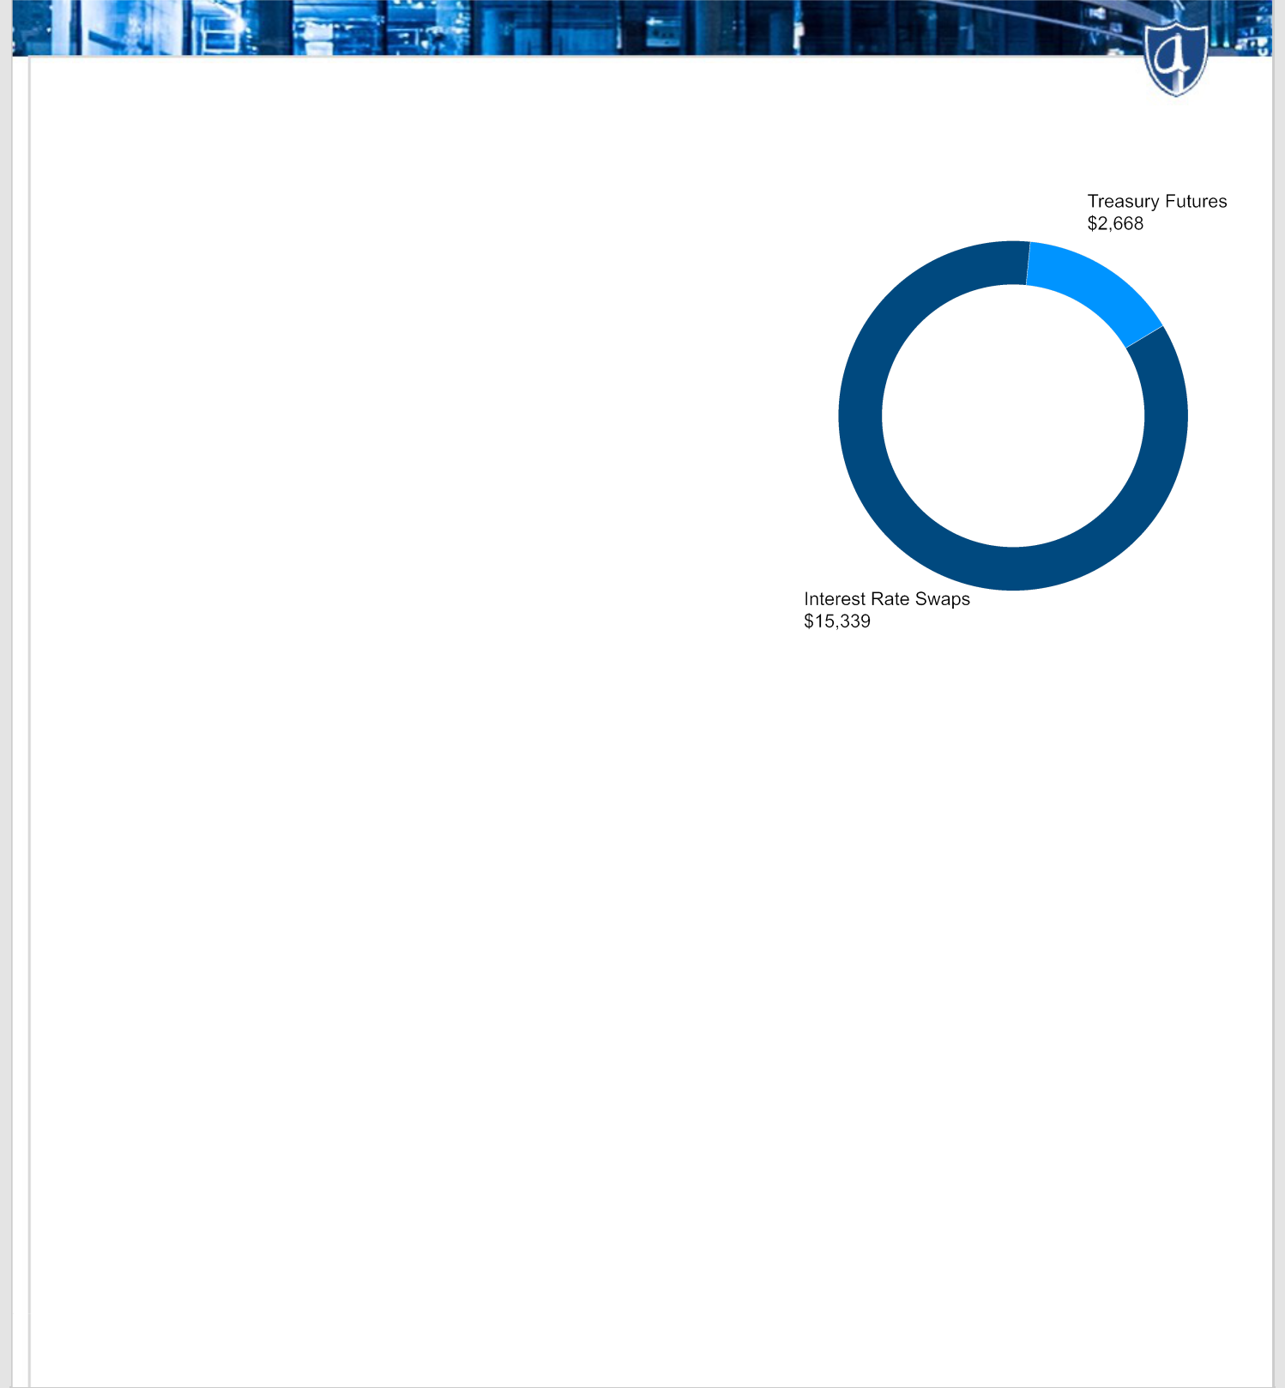

Certain statements made in this presentation regarding ARMOUR Residential REIT, Inc. (“ARMOUR” or the “Company”), and any other statements regarding ARMOUR’s future expectations, beliefs, goals or prospects constitute “forward-looking statements” made within the meaning of the safe harbor provisions of the United States Private Securities Litigation Reform Act of 1995. Any statements that are not statements of historical fact (including statements containing the words “expect,” “estimate,” “project,” “budget,” “forecast,” “anticipate,” “intend,” “plan,” “may,” “will,” “could,” “should,” “believes,” “predicts,” “potential,” “continue,” and similar expressions) should also be considered forward-looking statements. Forward-looking statements include but are not limited to statements regarding the projections and future plans for ARMOUR’s business, growth and operational improvements. Because forward-looking statements relate to the future, they are subject to inherent uncertainties, risks and changes in circumstances that are difficult to predict and many of which are outside of ARMOUR’s control. A number of important factors could cause actual results or events to differ materially from those indicated by such forward-looking statements. Additional information concerning these factors and risks are contained in the Company’s most recent annual and quarterly reports and other reports filed with the Securities and Exchange Commission. ARMOUR assumes no obligation to update the information in this communication, except as otherwise required by law. Readers are cautioned not to place undue reliance on these forward-looking statements, which speak only as of the date hereof.

This material is for information purposes only and does not constitute an offer to sell, a solicitation of an offer to buy, or a recommendation for any securities or financial instruments. The statements, information and estimates contained herein are based on information that the Company believes to be reliable as of today's date unless otherwise indicated. ARMOUR cannot guarantee future results, levels of activity, performance or achievements.

Pricing and duration information are estimates provided by independent third-party providers based on models that require inputs and assumptions. Actual realized prices and durations will depend on a number of factors that cannot be predicted with certainty and may be materially different from estimates.

AMOUNTS MAY NOT FOOT DUE TO ROUNDING.

THE INFORMATION PRESENTED HEREIN IS UNAUDITED AND NOT REVIEWED BY OUR INDEPENDENT PUBLIC ACCOUNTANTS.

Footnotes

- Total Repo divided by Shareholders’ Equity.

- Implied Leverage is Total Repo plus TBA market value net of forward settling trades divided by Shareholders’ Equity.

- Liquidity is cash plus unencumbered Agency and US Government securities. Excludes any forward settling trades.

- BUCKLER Securities LLC is an SEC registered broker-dealer and a member of FICC and FINRA that is affiliated with ARMOUR.

- Repo composition includes funding for US Treasury longs and margin collateral posted to ARMOUR.

- ARMOUR’s Treasury Futures have a weighted average duration of 11.2 years.

Portfolio and Key Data as of 05/31/26, except CPR which is as of 06/04/26 or as stated otherwise.

