UNITED STATES
SECURITIES AND EXCHANGE COMMISSION
WASHINGTON, D.C. 20549
_____________
FORM 8-K
______________
CURRENT REPORT PURSUANT TO SECTION 13 OR 15(d) OF THE SECURITIES EXCHANGE ACT OF 1934

Date of Report (Date of earliest event reported) July 22, 2026

ARMOUR Residential REIT, Inc.
(Exact Name of Registrant as Specified in Its Charter)
Maryland |  |  | 001-34766 |  |  | 26-1908763
(State or Other Jurisdiction  of Incorporation) |  |  | (Commission File Number) |  |  | (I.R.S. Employer Identification No.)
3001 Ocean Drive, Suite 201
Vero Beach, |  |  | Florida |  |  |  |  |  | 32963
(Address of Principal Executive Offices) |  |  |  |  |  |  |  |  | (Zip Code)

(772) 617-4340
(Registrant’s Telephone Number, Including Area Code)

n/a
(Former Name or Former Address, if Changed Since Last Report)

Check the appropriate box below if the Form 8-K filing is intended to simultaneously satisfy the filing obligation of the registrant under any of the following provisions (see General Instruction A.2. below):
☐ Written communications pursuant to Rule 425 under the Securities Act (17 CFR 230.425)
☐ Soliciting material pursuant to Rule 14a-12 under the Exchange Act (17 CFR 240.14a-12)
☐ Pre-commencement communications pursuant to Rule 14d-2(b) under the Exchange Act (17 CFR 240.14d-2(b))
☐ Pre-commencement communications pursuant to Rule 13e-4(c) under the Exchange Act (17 CFR 240.13e-4(c))
Securities registered pursuant to Section 12(b) of the Act:
Title of Each Class |  |  |  |  |  | Trading symbols |  |  |  |  |  | Name of Exchange on which registered
Preferred Stock, 7.00% Series C Cumulative Redeemable |  |  |  |  |  | ARR-PRC |  |  |  |  |  | New York Stock Exchange
Common Stock, $0.001 par value |  |  |  |  |  | ARR |  |  |  |  |  | New York Stock Exchange
Indicate by check mark whether the registrant is an emerging growth company as defined in Rule 405 of the Securities Act of 1933 (§230.405 of this chapter) or Rule 12b-2 of the Securities Exchange Act of 1934 (§240.12b-2 of this chapter).

Emerging growth company ☐

If an emerging growth company, indicate by a check mark if the registrant has elected not to use the extended transition period for complying with any new or revised financial accounting standards provided pursuant to Section 13(a) of the Exchange Act ☐

Item 2.02. Results of Operations and Financial Condition.

On July 22, 2026, ARMOUR Residential REIT, Inc. (the “Company”) issued a press release announcing its unaudited Q2 results and June 30, 2026 financial position. A copy of the press release is furnished as Exhibit 99.1 to this current report on Form 8-K.

The information furnished pursuant to this Item 2.02, including Exhibit 99.1, shall not be deemed “filed” for purposes of Section 18 of the Securities Exchange Act of 1934, as amended (the “Exchange Act”), or otherwise subject to liabilities under that section and shall not be deemed to be incorporated by reference into any filing of the Company under the Securities Act of 1933, as amended, or the Exchange Act, except as shall be expressly set forth by specific reference in such filing.

Item 7.01. Regulation FD Disclosure.

On July 22, 2026, ARMOUR produced for distribution a presentation, which contains updates on ARMOUR's financial position, business and operations. A copy of the presentation is furnished as Exhibit 99.2 to this current report of Form 8-K.

The information furnished pursuant to this Item 7.01, including Exhibit 99.2, shall not be deemed “filed” for
purposes of Section 18 of the Exchange Act, or otherwise subject to liabilities under that section and shall not be deemed to be incorporated by reference into any filing of the Company under the Securities Act of 1933, as amended, or the Exchange Act, except as shall be expressly set forth by specific reference in such filing.

Item 9.01. Financial Statements and Exhibits.

(d) Exhibits

Exhibit No. |  |  | Description
99.1 |  |  | Press Release dated July 22, 2026
99.2 |  |  | Presentation dated July 22, 2026
104 |  |  | Cover Page Interactive Data File (embedded within the Inline XBRL document)

SIGNATURES

Pursuant to the requirements of the Securities Exchange Act of 1934, the Registrant has duly caused this report to be signed on its behalf by the undersigned hereunto duly authorized.

Dated: July 22, 2026
 |  |  | ARMOUR RESIDENTIAL REIT, INC.
 |  |  | By: |  |  | /s/ Gordon M. Harper
 |  |  | Name: |  |  | Gordon M. Harper
 |  |  | Title: |  |  | Chief Financial Officer


ARMOUR RESIDENTIAL REIT, INC. ANNOUNCES
Q2 RESULTS AND JUNE 30, 2026 FINANCIAL POSITION

VERO BEACH, Florida -- July 22, 2026 -- ARMOUR Residential REIT, Inc. (NYSE: ARR and ARR PRC) (“ARMOUR” or the “Company”) today announced the Company's unaudited Q2 results and June 30, 2026 financial position.

Q2 2026 Results
◦GAAP net income related to common stockholders of $111.5 million or $0.86 per common share.
◦Q2 2026 total economic return was 4.8%, which is change in book value for the period plus common dividends paid for the quarter.
◦Net interest income of $76.8 million.
◦Distributable Earnings available to common stockholders of $93.2 million, which represents $0.72 per common share (see explanation of this non-GAAP measure on page 5).
◦Average interest income on interest earning assets of 4.93% and interest cost on average interest bearing liabilities of 3.83%.
◦Economic interest income was 4.86% less economic interest expense of 3.04% for an economic net interest spread of 1.82% (see explanation of this non-GAAP measure on page 7).
◦Raised $218.7 million of capital by issuing 12,714,990 shares of common stock through an at the market offering program.
◦Raised $4.1 million of capital by issuing 197,939 shares of preferred stock through an at the market offering program.
◦Paid common stock dividends of $0.24 per share per month, or $0.72 per share for Q2.
June 30, 2026 Financial Position
◦Book value per common share of $17.53, up 0.6% compared to $17.42 at March 31, 2026.
◦Liquidity, including cash and unencumbered securities, of $1.2 billion.
◦Portfolio totaled $21.8 billion, comprised of 94.5% Agency mortgage-backed securities ("MBS") and 2.7% U.S. Treasury Securities and 2.8% of To Be Announced ("TBA") Agency Securities.
◦Repurchase agreements, net totaled $19.4 billion; 46.8% were with ARMOUR affiliate BUCKLER Securities LLC.
◦Debt to equity ratio of 7.54:1 (based on repurchase agreements divided by total stockholders’ equity). Implied leverage, including TBA Agency Securities and forward settling sales and unsettled purchases was 7.73:1.
◦Interest Rate swap contracts totaled $15.9 billion of notional amount.
Management's Remarks
"The Company delivered strong results for the second quarter of 2026, with total economic return of 4.8%, despite a macroeconomic backdrop that would normally weigh on our sector." said Scott Ulm, the Company's Chief Executive Officer. "We continue to prioritize maintaining common share dividends appropriate for the intermediate term rather than focusing on short-term market fluctuations. Our approach remains unchanged. We stress test our liquidity, apply systematic hedging and deploy capital appropriately. We are well positioned to attenuate downside risks while taking advantage of opportunities that present themselves.“

- MORE -

ARMOUR Residential REIT, Inc. Announces Q2 Results and June 30, 2026 Financial Position Page 2
July 22, 2026
Company Update, July 20, 2026
◦Common stock outstanding of 141,553,046 shares.
◦Liquidity, including cash and unencumbered securities, exceeded $1.1 billion, this excludes MBS principal and interest receivable due in July 2026 which totaled $277.1 million.
◦Securities portfolio included approximately $22.1 billion of Agency MBS (including TBA Agency Securities) and U.S. Treasury Securities.
◦Through July 14, 2026 we raised approximately $88.3 million of capital by issuing 5,182,253 shares of common stock and $0.1 million of capital by issuing 3,983 shares of preferred stock through at the market offering programs.
◦Debt to equity ratio (based on repurchase agreements divided by total stockholders' equity) was 7.52 to 1; Implied leverage, including TBA Agency Securities and forward settling sales and unsettled purchases was 7.86 to 1.
Book value per common share consisted of:
 |  |  |  |  |  | June 30, 2026 |  |  |  |  |  | December 31, 2025
Stockholders' Equity |  |  |  |  |  | (in millions except per share)
Common stock, at par value - 136,370,793 and 111,915,020 shares outstanding, respectively |  |  |  |  |  | $ | 0.1 |  |  |  |  | $ | 0.1
Additional paid-in capital |  |  |  |  |  | 5,890.0 |  |  |  |  |  | 5,446.2
Cumulative distributions to stockholders |  |  |  |  |  | (2,852.8) |  |  |  |  |  | (2,667.1)
Accumulated net loss |  |  |  |  |  | (458.2) |  |  |  |  |  | (518.2)
Total Stockholders' Equity |  |  |  |  |  | $ | 2,579.1 |  |  |  |  | $ | 2,261.0
Less: liquidation preference - 7.00% Cumulative Redeemable Preferred C Stock - 7,552,594 and 7,047,832 shares outstanding |  |  |  |  |  | (188.8) |  |  |  |  |  | (176.2)
Equity Attributable to Common Stockholders |  |  |  |  |  | $ | 2,390.3 |  |  |  |  | $ | 2,084.8
Book value per common share |  |  |  |  |  | $ | 17.53 |  |  |  |  | $ | 18.63

- MORE -

ARMOUR Residential REIT, Inc. Announces Q2 Results and June 30, 2026 Financial Position Page 3
July 22, 2026
The major drivers of the change in the Company's financial position were:
 |  |  |  |  |  | Q2 2026 |  |  |  |  |  | Q1 2026
 |  |  |  |  |  | (in millions)
Total Stockholders' Equity – Beginning |  |  |  |  |  | $ | 2,337.0 |  |  |  |  | $ | 2,261.0
Income
Investment in securities:
Loss on MBS |  |  |  |  |  | $ | (42.6) |  |  |  |  | $ | (182.6)
Loss on U.S. Treasury Securities |  |  |  |  |  | (10.4) |  |  |  |  |  | (10.6)
Gain (Loss) on TBA Agency Securities |  |  |  |  |  | 1.9 |  |  |  |  |  | (7.1)
Gain on interest rate swaps |  |  |  |  |  | 110.8 |  |  |  |  |  | 71.3
Gain (Loss) on futures contracts |  |  |  |  |  | (4.5) |  |  |  |  |  | 18.8
Net Interest Income |  |  |  |  |  | 76.8 |  |  |  |  |  | 70.7
Total Expenses |  |  |  |  |  | (17.2) |  |  |  |  |  | (15.3)
Net Income (Loss) |  |  |  |  |  | $ | 114.8 |  |  |  |  | $ | (54.8)
Preferred stock dividends |  |  |  |  |  | (3.3) |  |  |  |  |  | (3.2)
Common stock dividends |  |  |  |  |  | (93.1) |  |  |  |  |  | (86.3)
Capital Activities
Issuance of Preferred stock |  |  |  |  |  | 4.1 |  |  |  |  |  | 6.4
Issuance of common stock |  |  |  |  |  | 219.6 |  |  |  |  |  | 215.9
Common shares repurchased |  |  |  |  |  | — |  |  |  |  |  | (2.0)
Total Stockholders' Equity – Ending |  |  |  |  |  | $ | 2,579.1 |  |  |  |  | $ | 2,337.0

- MORE -

ARMOUR Residential REIT, Inc. Announces Q2 Results and June 30, 2026 Financial Position Page 4
July 22, 2026
Condensed Balance Sheet (unaudited)
 |  |  |  |  |  | June 30, 2026 |  |  |  |  |  | December 31, 2025
 |  |  |  |  |  | (in millions)
Assets
Cash and cash equivalents |  |  |  |  |  | $ | 83.7 |  |  |  |  | $ | 63.3
Cash collateral posted to counterparties |  |  |  |  |  | 351.8 |  |  |  |  |  | 226.7
Agency Securities, at fair value |  |  |  |  |  | 20,596.3 |  |  |  |  |  | 19,417.6
U.S. Treasury Securities, at fair value |  |  |  |  |  | 587.3 |  |  |  |  |  | 598.1
Receivable for unsettled sales |  |  |  |  |  | 344.4 |  |  |  |  |  | —
Derivatives, at fair value |  |  |  |  |  | 668.1 |  |  |  |  |  | 611.5
Accrued interest receivable |  |  |  |  |  | 91.3 |  |  |  |  |  | 86.2
Prepaid and other |  |  |  |  |  | 22.9 |  |  |  |  |  | 1.7
Total Assets |  |  |  |  |  | $ | 22,745.8 |  |  |  |  | $ | 21,005.1
Liabilities
Repurchase agreements, net |  |  |  |  |  | $ | 19,441.5 |  |  |  |  | $ | 17,941.8
Cash collateral posted by counterparties |  |  |  |  |  | 330.7 |  |  |  |  |  | 419.4
Payable for unsettled purchases |  |  |  |  |  | 241.1 |  |  |  |  |  | 302.1
Derivatives, at fair value |  |  |  |  |  | 75.2 |  |  |  |  |  | 19.3
Accrued interest payable- repurchase agreements |  |  |  |  |  | 72.3 |  |  |  |  |  | 59.3
Accounts payable and other accrued expenses |  |  |  |  |  | 5.9 |  |  |  |  |  | 2.2
Total Liabilities |  |  |  |  |  | $ | 20,166.7 |  |  |  |  | $ | 18,744.1
Stockholders’ Equity
7.00% Cumulative Redeemable Preferred C Stock ($0.001 par value per share, $25.00 per share liquidation preference) |  |  |  |  |  | $ | — |  |  |  |  | $ | —
Common stock ($0.001 par value per share) |  |  |  |  |  | 0.1 |  |  |  |  |  | 0.1
Additional paid-in capital |  |  |  |  |  | 5,890.0 |  |  |  |  |  | 5,446.2
Cumulative distributions to stockholders |  |  |  |  |  | (2,852.8) |  |  |  |  |  | (2,667.1)
Accumulated net loss |  |  |  |  |  | (458.2) |  |  |  |  |  | (518.2)
Total Stockholders’ Equity |  |  |  |  |  | 2,579.1 |  |  |  |  |  | 2,261.0
Total Liabilities and Stockholders’ Equity |  |  |  |  |  | $ | 22,745.8 |  |  |  |  | $ | 21,005.1

- MORE -

ARMOUR Residential REIT, Inc. Announces Q2 Results and June 30, 2026 Financial Position Page 5
July 22, 2026
Non-GAAP Financial Measures
Distributable Earnings
Distributable Earnings is a non-GAAP measure defined as net interest income plus TBA Drop Income adjusted for the net coupon effect of interest rate swaps and futures contracts minus net operating expenses. Distributable Earnings is based on the historical cost basis of our Agency Securities, interest rate swaps and futures contracts. Distributable Earnings differs, potentially significantly, from net interest income and from net income (loss) (which includes realized gains and losses and market value adjustments).
For a portion of its Agency Securities the Company may enter into TBA forward contracts for the purchase or sale of Agency Securities at a predetermined price, face amount, issuer, coupon and stated maturity on an agreed-upon future date, but the particular Agency Securities to be delivered are not identified until shortly before the TBA settlement date. The Company accounts for TBA Agency Securities as derivative instruments if it is reasonably possible that it will not take or make physical delivery of the Agency Securities upon settlement of the contract. The Company may choose, prior to settlement, to move the settlement of these securities out to a later date by entering into an offsetting short or long position (referred to as a “pair off”), net settling the paired off positions for cash, and simultaneously purchasing or selling a similar TBA Agency Security for a later settlement date. This transaction is commonly referred to as a “dollar roll.” The Company accounts for TBA dollar roll transactions as a series of derivative transactions.
Forward settling TBA contracts typically trade at a discount, or “Drop,” to the regular settled TBA contract to reflect the expected interest income on the underlying deliverable Agency Securities, net of an implied financing cost, which would have been earned by the buyer if the contract settled on the next regular settlement date. When the Company enters into TBA contracts to buy Agency Securities for forward settlement, it earns this “TBA Drop Income,” because the TBA contract is essentially equivalent to a leveraged investment in the underlying Agency Securities. The amount of TBA Drop Income is calculated as the difference between the spot price of similar TBA contracts for regular settlement and the forward settlement price on the trade date. The Company generally accounts for TBA contracts as derivatives and TBA Drop Income is included as part of the periodic changes in fair value of the TBA contracts that the Company recognizes currently in the Other Income (Loss) section of its Consolidated Statement of Operations.

Distributable Earnings and Distributable Earnings per common share
The Company believes that Distributable Earnings and Distributable Earnings per common share may be useful to investors because our Board of Directors may consider Distributable Earnings and Distributable Earnings per common share as part of its deliberations when determining the level of dividends on our common stock. Distributable Earnings and Distributable Earnings per common share tend to be more stable over time and this practice is designed to increase the stability of our common stock dividend from month to month. However, because Distributable Earnings is an incomplete measure of the Company’s financial performance and involves significant differences from net interest income and net income (loss) computed in accordance with GAAP, Distributable Earnings should be considered as supplementary to, and not as a substitute for, the Company’s net interest income and net income (loss) computed in accordance with GAAP as a measure of certain aspects of the Company’s financial performance.

- MORE -

ARMOUR Residential REIT, Inc. Announces Q2 Results and June 30, 2026 Financial Position Page 6
July 22, 2026
The below table shows the reconciliation of the elements of Distributable Earnings and Distributable Earnings per common share to the Company’s Net Interest Income, Net Income and Net Income per common share.
 |  |  |  |  |  | Q2 2026 |  |  |  |  |  | Q1 2026
($ in millions except,
share and per share)
Net Interest Income |  |  |  |  |  | $ | 76.8 |  |  |  |  | $ | 70.7
TBA Drop and interest margin income |  |  |  |  |  | 1.2 |  |  |  |  |  | 0.8
Net interest income on interest rate swaps |  |  |  |  |  | 33.3 |  |  |  |  |  | 35.7
Net interest income on futures contracts |  |  |  |  |  | 2.4 |  |  |  |  |  | 1.8
Total Expenses |  |  |  |  |  | (17.2) |  |  |  |  |  | (15.3)
Distributable Earnings |  |  |  |  |  | $ | 96.5 |  |  |  |  | $ | 93.7
Dividends on Preferred Stock |  |  |  |  |  | (3.3) |  |  |  |  |  | (3.2)
Distributable Earnings available to common stockholders |  |  |  |  |  | $ | 93.2 |  |  |  |  | $ | 90.5
Distributable Earnings per common share |  |  |  |  |  | $ | 0.72 |  |  |  |  | $ | 0.76
Net Income (Loss) |  |  |  |  |  | $ | 114.8 |  |  |  |  | $ | (54.8)
Items Excluded from Distributable Earnings:
Loss on MBS |  |  |  |  |  | 42.6 |  |  |  |  |  | 182.6
Loss on U.S. Treasury Securities |  |  |  |  |  | 10.4 |  |  |  |  |  | 10.6
(Gain) Loss on TBA Agency Securities, less TBA Drop Income |  |  |  |  |  | (0.7) |  |  |  |  |  | 7.9
(Gain) on futures contracts |  |  |  |  |  | 6.9 |  |  |  |  |  | (17.0)
Gain on interest rate swaps |  |  |  |  |  | (77.5) |  |  |  |  |  | (35.6)
Total items excluded |  |  |  |  |  | $ | (18.3) |  |  |  |  | $ | 148.5
Distributable Earnings |  |  |  |  |  | $ | 96.5 |  |  |  |  | $ | 93.7
Dividends on Preferred Stock |  |  |  |  |  | (3.3) |  |  |  |  |  | (3.2)
Distributable Earnings available to common stockholders |  |  |  |  |  | $ | 93.2 |  |  |  |  | $ | 90.5
Distributable Earnings per common share |  |  |  |  |  | $ | 0.72 |  |  |  |  | $ | 0.76
Net Income (Loss) |  |  |  |  |  | $ | 114.8 |  |  |  |  | $ | (54.8)
Dividends on Preferred Stock |  |  |  |  |  | (3.3) |  |  |  |  |  | (3.2)
Net Income (Loss) available (related) to common stockholders |  |  |  |  |  | $ | 111.5 |  |  |  |  | $ | (58.0)
Net Income (Loss) per common share |  |  |  |  |  | $ | 0.86 |  |  |  |  | $ | (0.49)
Weighted average common shares outstanding |  |  |  |  |  | 130,018,574 |  |  |  |  |  | 119,578,741
- MORE -

ARMOUR Residential REIT, Inc. Announces Q2 Results and June 30, 2026 Financial Position Page 7
July 22, 2026
Economic Interest Income, Economic Interest Expense, Economic Net Interest Income/Net Interest Spread and Economic Net Yield on Interest Earning Assets
The Company believes that these non-GAAP measures, which include the effects of TBA drop income and net interest income (expense) on interest rate swaps and futures contracts, may be useful to investors because they reflect items that we consider in the management of the Company’s investment portfolio and related funding. The Company believes that the inclusion in economic net interest income of interest rate swaps and futures contracts, which are recognized under GAAP in gain/loss on derivative instruments, is meaningful as interest rate swaps are the primary instrument the Company uses to economically hedge against fluctuations in the Company’s borrowing costs and their inclusion is more indicative of the Company’s total cost of funds than interest expense alone. It does not include all interest earning assets and interest bearing liabilities, such as cash collateral posted by counterparties. Accordingly, it is not a substitute for net interest income or net income (loss) determined in accordance with GAAP and should be considered as supplementary to such GAAP measures as a measure of certain aspects of the Company’s financial performance.
 |  |  |  |  |  | Q2 2026 |  |  |  |  |  |  |  |  |  |  |  |  |  |  |  |  |  | Q1 2026
 |  |  |  |  |  | (in millions) |  |  |  |  |  |  |  |  |  |  |  |  |  |  |  |  |  | (in millions)
 |  |  |  |  |  | Income (Expense) |  |  |  |  |  | Average Balance |  |  |  |  |  | Average Rate |  |  |  |  |  | Income (Expense) |  |  |  |  |  | Average Balance |  |  |  |  |  | Average Rate
Interest Bearing Assets:
Agency Securities, Net of Amortization |  |  |  |  |  | $ | 254.4 |  |  |  |  | $ | 20,477.7 |  |  |  |  | 4.97 |  | % |  |  |  | $ | 242.0 |  |  |  |  | $ | 19,497.7 |  |  |  |  | 4.97 |  | %
Cash Equivalents & Treasury Securities |  |  |  |  |  | 9.5 |  |  |  |  |  | 941.9 |  |  |  |  |  | 4.03 |  | % |  |  |  | 7.2 |  |  |  |  |  | 918.8 |  |  |  |  |  | 3.12 |  | %
Total Interest Income/Average Interest Earning Assets |  |  |  |  |  | 263.9 |  |  |  |  |  | 21,419.6 |  |  |  |  |  | 4.93 |  | % |  |  |  | 249.2 |  |  |  |  |  | 20,416.5 |  |  |  |  |  | 4.88 |  | %
TBA drop income (loss)/Implied Average TBA Agency Securities |  |  |  |  |  | 1.2 |  |  |  |  |  | 395.6 |  |  |  |  |  | 1.20 |  | % |  |  |  | 0.8 |  |  |  |  |  | 326.7 |  |  |  |  |  | 0.98 |  | %
Economic interest income |  |  |  |  |  | $ | 265.1 |  |  |  |  | $ | 21,815.2 |  |  |  |  | 4.86 |  | % |  |  |  | $ | 250.0 |  |  |  |  | $ | 20,743.2 |  |  |  |  | 4.82 |  | %
Interest Bearing Liabilities:
Repurchase Agreements |  |  |  |  |  | $ | (187.1) |  |  |  |  | $ | 19,558.9 |  |  |  |  | (3.83) |  | % |  |  |  | $ | (178.5) |  |  |  |  | $ | 18,579.0 |  |  |  |  | (3.84) |  | %
Total Interest Expense/Average Interest Bearing Liabilities |  |  |  |  |  | (187.1) |  |  |  |  |  | 19,558.9 |  |  |  |  |  | (3.83) |  | % |  |  |  | (178.5) |  |  |  |  |  | 18,579.0 |  |  |  |  |  | (3.84) |  | %
Implied Average TBA Funding Positions |  |  |  |  |  | — |  |  |  |  |  | 392.0 |  |  |  |  |  | — |  | % |  |  |  | — |  |  |  |  |  | 321.0 |  |  |  |  |  | — |  | %
Net interest income (expense) on interest rate swaps |  |  |  |  |  | 33.3 |  |  |  |  |  | — |  |  |  |  |  | 0.68 |  | % |  |  |  | 35.7 |  |  |  |  |  | — |  |  |  |  |  | 0.77 |  | %
Net interest income (expense) on futures contracts |  |  |  |  |  | 2.4 |  |  |  |  |  | — |  |  |  |  |  | 0.05 |  | % |  |  |  | 1.8 |  |  |  |  |  | — |  |  |  |  |  | 0.04 |  | %
Economic interest expense |  |  |  |  |  | $ | (151.4) |  |  |  |  | $ | 19,950.9 |  |  |  |  | (3.04) |  | % |  |  |  | $ | (141.0) |  |  |  |  | $ | 18,900.0 |  |  |  |  | (2.98) |  | %
Economic net interest income/net interest spread |  |  |  |  |  | $ | 113.7 |  |  |  |  |  |  |  |  |  |  | 1.82 |  | % |  |  |  | $ | 109.0 |  |  |  |  |  |  |  |  |  |  | 1.84 |  | %
Economic net yield on interest earning assets |  |  |  |  |  |  |  |  |  |  |  |  |  |  |  |  |  | 2.08 |  | % |  |  |  |  |  |  |  |  |  |  |  |  |  |  |  | 2.10 |  | %

- MORE -

ARMOUR Residential REIT, Inc. Announces Q2 Results and June 30, 2026 Financial Position Page 8
July 22, 2026
Conference Call
As previously announced, the Company will provide an online, real-time webcast of its conference call with equity analysts covering Q2 2026 operating results on Thursday, July 23, 2026, at 8:00 a.m. (Eastern Time). The live broadcast will be available online and can be accessed at https://event.choruscall.com/mediaframe/webcast.html?webcastid=wQ5O4Se4. To monitor the live webcast, please visit the website at least 15 minutes prior to the start of the call to register, download, and install any necessary audio software. An online replay of the event will be available on the Company’s website at www.armourreit.com and continue for one year.

Dividends
ARMOUR paid monthly cash dividends of $0.24 per share of the Company’s common stock for each month in Q2 2026. On July 30, 2026, a cash dividend of $0.24 per outstanding common share will be paid to holders of record on July 15, 2026. We have also declared a cash dividend of $0.24 per outstanding common share payable August 28, 2026 to holders of record on August 17, 2026. ARMOUR’s Board of Directors will determine future common dividend rates based on an evaluation of the Company’s results, financial position, real estate investment trust (“REIT”) tax requirements, and overall market conditions as the quarter progresses. In order to maintain ARMOUR’s tax status as a REIT, the Company is required to timely distribute substantially all of its ordinary REIT taxable income for the tax year.
ARMOUR paid monthly cash dividends of $0.14583 per share of the Company’s Series C Preferred Stock for each month in Q2 2026. On July 27, 2026, a cash dividend of $0.14583 per outstanding share of Series C Preferred Stock will be paid to holders of record on July 15, 2026. We have also declared cash dividends of $0.14583 per outstanding share of Series C Preferred Stock payable August 27, 2026 and September 28, 2026, to holders of record on August 15, 2026 and September 15, 2026, respectively.

ARMOUR Residential REIT, Inc.
ARMOUR invests primarily in fixed rate residential, adjustable rate and hybrid adjustable rate residential mortgage-backed securities issued or guaranteed by U.S. Government-sponsored enterprises or guaranteed by the Government National Mortgage Association. ARMOUR is externally managed and advised by ARMOUR Capital Management LP, an investment advisor registered with the Securities and Exchange Commission (“SEC”).

Safe Harbor
This press release includes “forward-looking statements” within the meaning of the safe harbor provisions of the United States Private Securities Litigation Reform Act of 1995. Actual results may differ from expectations, estimates and projections and, consequently, you should not rely on these forward-looking statements as predictions of future events. Words such as “expect,” “estimate,” “project,” “budget,” “forecast,” “anticipate,” “intend,” “plan,” “may,” “will,” “could,” “should,” “believes,” “predicts,” “potential,” “continue,” and similar expressions are intended to identify such forward-looking statements. These forward-looking statements involve significant risks and uncertainties that could cause the actual results to differ materially from the expected results. Additional information concerning these and other risk factors are contained in the Company’s most recent filings with the SEC. All subsequent written and oral forward-looking statements concerning the Company are expressly qualified in their entirety by the cautionary statements above. The Company cautions readers not to place undue reliance upon any forward-looking statements, which speak only as of the date made. The Company does not undertake or accept any obligation or undertaking to release publicly any updates or revisions to any forward-looking statements to reflect any change in its expectations or any change in events, conditions or circumstances on which any such statement is based, except as required by law.

- MORE -

ARMOUR Residential REIT, Inc. Announces Q2 Results and June 30, 2026 Financial Position Page 9
July 22, 2026

Additional Information
Investors, security holders and other interested persons may find ARMOUR's most recent Company Update and additional information regarding the Company at the SEC’s internet site at www.sec.gov, or the Company website at www.armourreit.com or by directing requests to: ARMOUR Residential REIT, Inc., 3001 Ocean Drive, Suite 201, Vero Beach, Florida 32963, Attention: Investor Relations.

Contact
Gordon M. Harper, Chief Financial Officer, ARR, (772) 617-4340, investor@armourreit.com
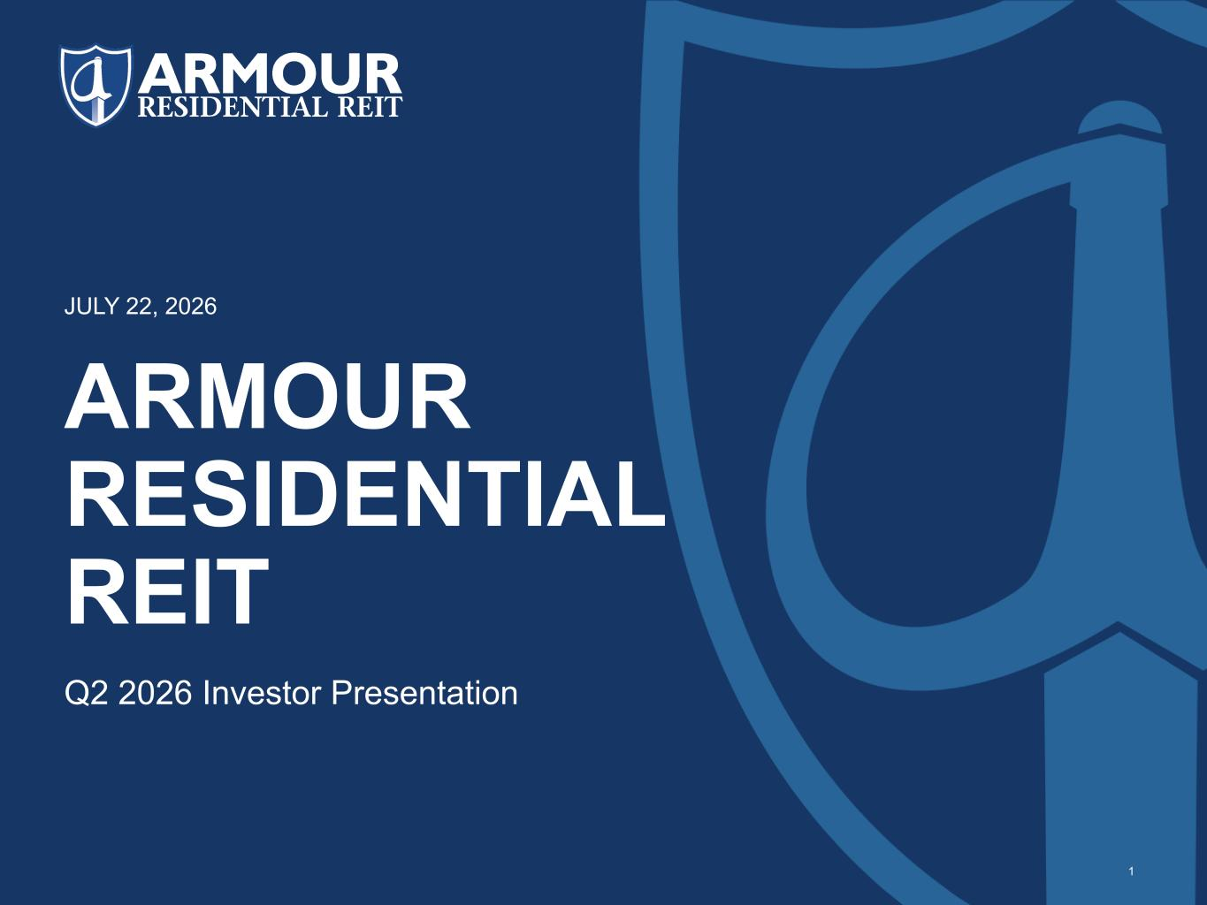
- END -
ARMOUR RESIDENTIAL REIT Q2 2026 Investor Presentation JULY 22, 2026 1

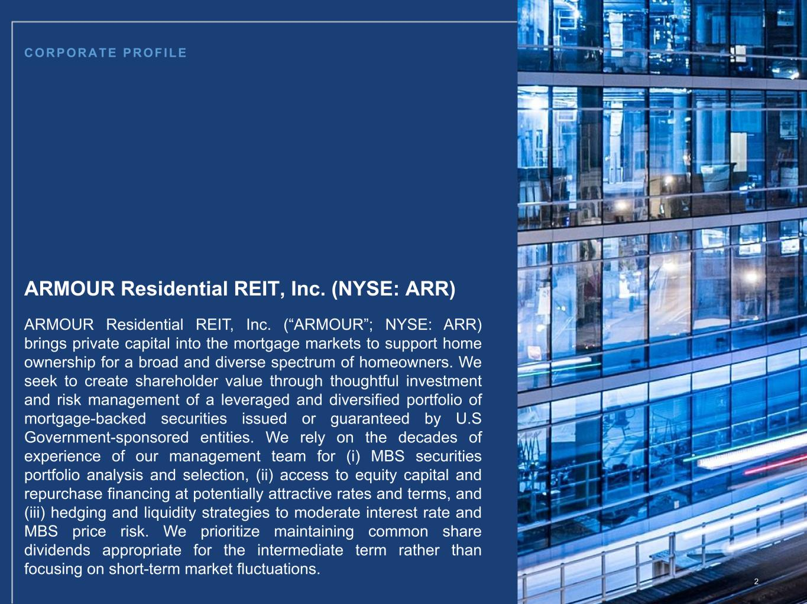
CORPORATE PROFILE 2 ARMOUR Residential REIT, Inc. (NYSE: ARR) ARMOUR Residential REIT, Inc. (“ARMOUR”; NYSE: ARR) brings private capital into the mortgage markets to support home ownership for a broad and diverse spectrum of homeowners. We seek to create shareholder value through thoughtful investment and risk management of a leveraged and diversified portfolio of mortgage-backed securities issued or guaranteed by U.S Government-sponsored entities. We rely on the decades of experience of our management team for (i) MBS securities portfolio analysis and selection, (ii) access to equity capital and repurchase financing at potentially attractive rates and terms, and (iii) hedging and liquidity strategies to moderate interest rate and MBS price risk. We prioritize maintaining common share dividends appropriate for the intermediate term rather than focusing on short-term market fluctuations.

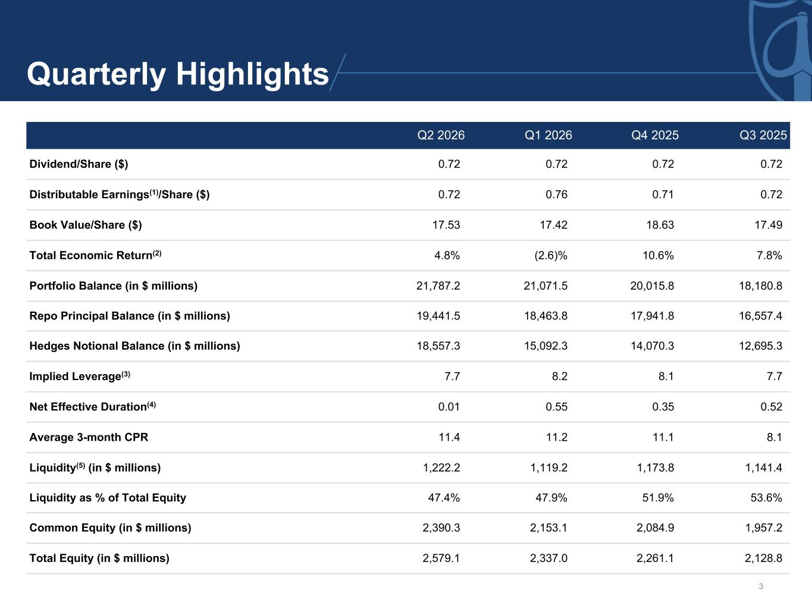
Quarterly Highlights Q2 2026 Q1 2026 Q4 2025 Q3 2025 Dividend/Share ($) 0.72 0.72 0.72 0.72 Distributable Earnings(1)/Share ($) 0.72 0.76 0.71 0.72 Book Value/Share ($) 17.53 17.42 18.63 17.49 Total Economic Return(2) 4.8 % (2.6) % 10.6 % 7.8 % Portfolio Balance (in $ millions) 21,787.2 21,071.5 20,015.8 18,180.8 Repo Principal Balance (in $ millions) 19,441.5 18,463.8 17,941.8 16,557.4 Hedges Notional Balance (in $ millions) 18,557.3 15,092.3 14,070.3 12,695.3 Implied Leverage(3) 7.7 8.2 8.1 7.7 Net Effective Duration(4) 0.01 0.55 0.35 0.52 Average 3-month CPR 11.4 11.2 11.1 8.1 Liquidity(5) (in $ millions) 1,222.2 1,119.2 1,173.8 1,141.4 Liquidity as % of Total Equity 47.4 % 47.9 % 51.9 % 53.6 % Common Equity (in $ millions) 2,390.3 2,153.1 2,084.9 1,957.2 Total Equity (in $ millions) 2,579.1 2,337.0 2,261.1 2,128.8 3

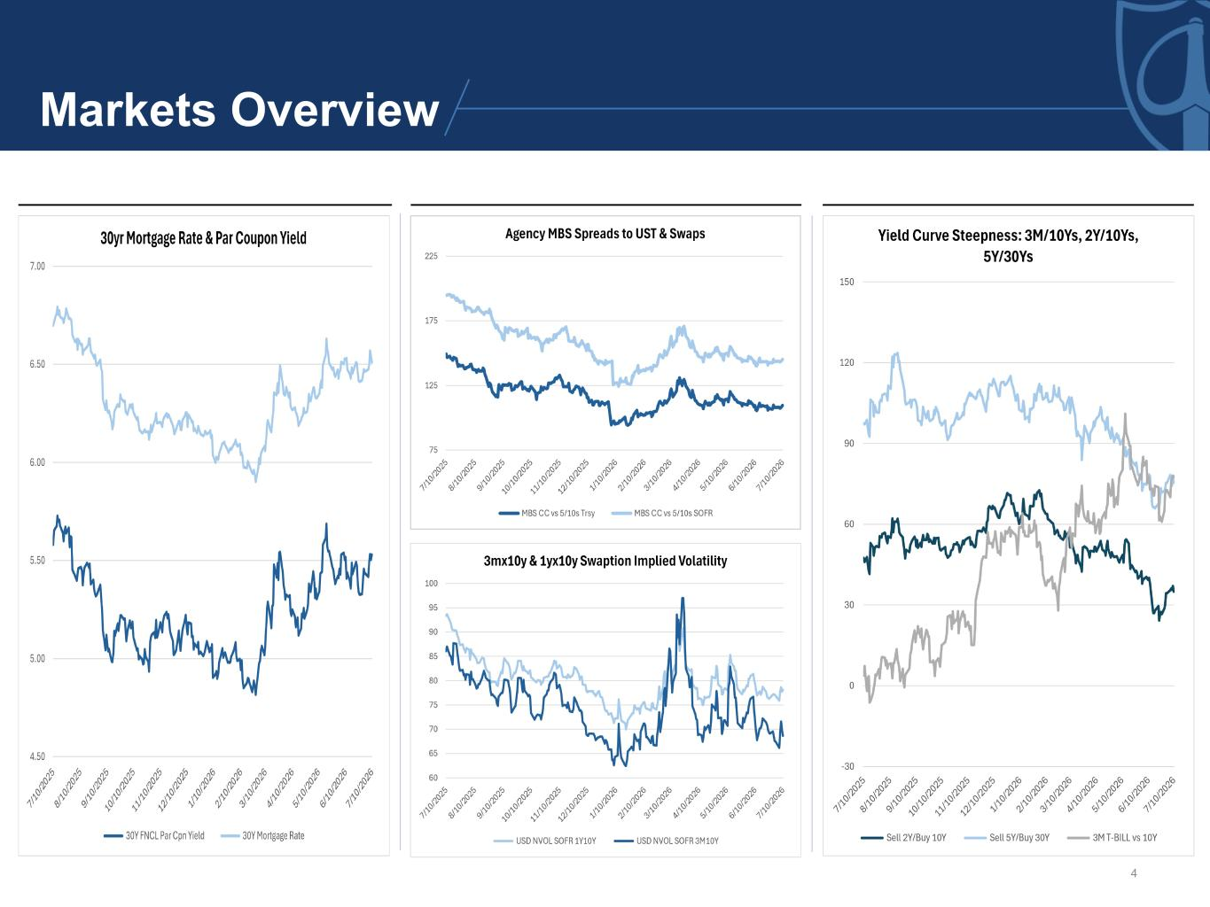
4 Markets Overview


Investment Portfolio 5 as of 6/30/2026

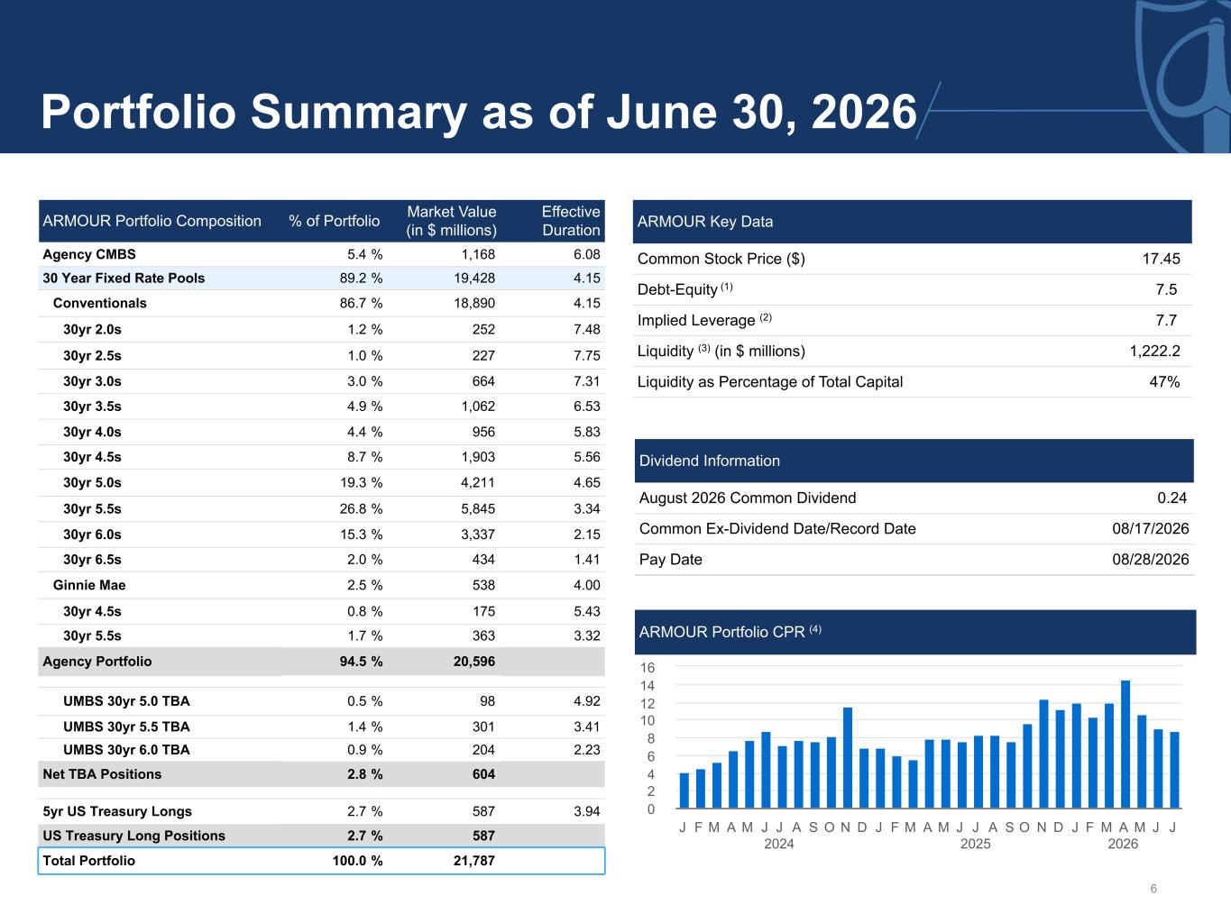
6 Portfolio Summary as of June 30, 2026 ARMOUR Portfolio Composition % of Portfolio Market Value (in $ millions) Effective Duration Agency CMBS 5.4 % 1,168 6.08 30 Year Fixed Rate Pools 89.2 % 19,428 4.15 Conventionals 86.7 % 18,890 4.15 30yr 2.0s 1.2 % 252 7.48 30yr 2.5s 1.0 % 227 7.75 30yr 3.0s 3.0 % 664 7.31 30yr 3.5s 4.9 % 1,062 6.53 30yr 4.0s 4.4 % 956 5.83 30yr 4.5s 8.7 % 1,903 5.56 30yr 5.0s 19.3 % 4,211 4.65 30yr 5.5s 26.8 % 5,845 3.34 30yr 6.0s 15.3 % 3,337 2.15 30yr 6.5s 2.0 % 434 1.41 Ginnie Mae 2.5 % 538 4.00 30yr 4.5s 0.8 % 175 5.43 30yr 5.5s 1.7 % 363 3.32 Agency Portfolio 94.5 % 20,596 UMBS 30yr 5.0 TBA 0.5 % 98 4.92 UMBS 30yr 5.5 TBA 1.4 % 301 3.41 UMBS 30yr 6.0 TBA 0.9 % 204 2.23 Net TBA Positions 2.8 % 604 5yr US Treasury Longs 2.7 % 587 3.94 US Treasury Long Positions 2.7 % 587 Total Portfolio 100.0 % 21,787 ARMOUR Key Data Common Stock Price ($) 17.45 Debt-Equity (1) 7.5 Implied Leverage (2) 7.7 Liquidity (3) (in $ millions) 1,222.2 Liquidity as Percentage of Total Capital 47 % Dividend Information August 2026 Common Dividend 0.24 Common Ex-Dividend Date/Record Date 08/17/2026 Pay Date 08/28/2026 ARMOUR Portfolio CPR (4) J F M A M J J 2024 A S O N D J F M A M J J 2025 A S O N D J F M A 2026 M J J 0 2 4 6 8 10 12 14 16

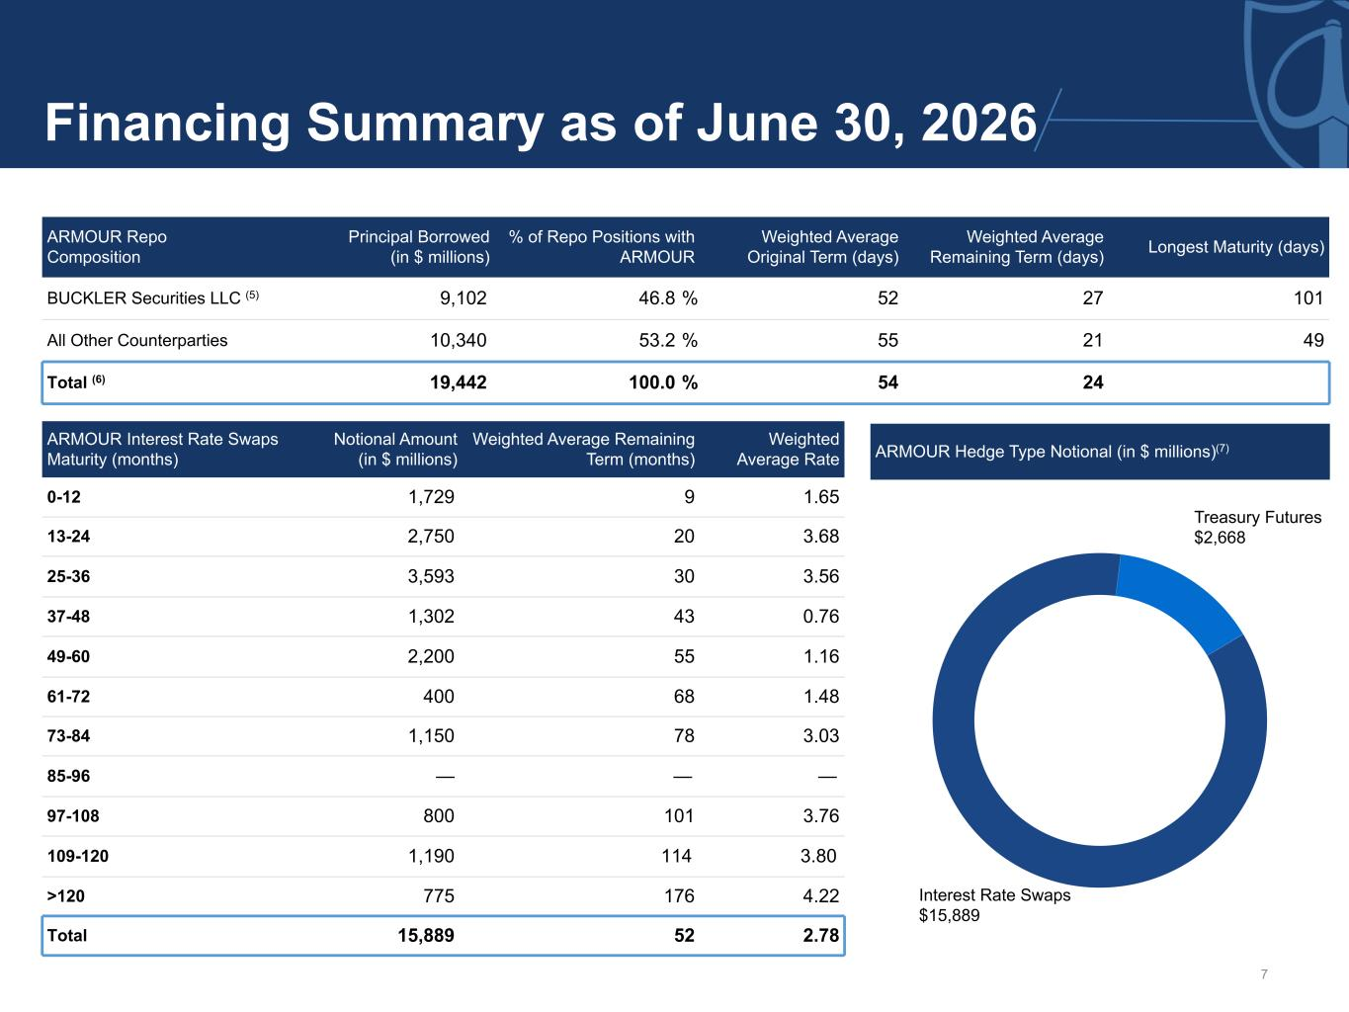
7 Financing Summary as of June 30, 2026 ARMOUR Hedge Type Notional (in $ millions)(7) ARMOUR Repo Composition Principal Borrowed (in $ millions) % of Repo Positions with ARMOUR Weighted Average Original Term (days) Weighted Average Remaining Term (days) Longest Maturity (days) BUCKLER Securities LLC (5) 9,102 46.8 % 52 27 101 All Other Counterparties 10,340 53.2 % 55 21 49 Total (6) 19,442 100.0 % 54 24 ARMOUR Interest Rate Swaps Maturity (months) Notional Amount (in $ millions) Weighted Average Remaining Term (months) Weighted Average Rate 0-12 1,729 9 1.65 13-24 2,750 20 3.68 25-36 3,593 30 3.56 37-48 1,302 43 0.76 49-60 2,200 55 1.16 61-72 400 68 1.48 73-84 1,150 78 3.03 85-96 — — — 97-108 800 101 3.76 109-120 1,190 114 3.80 >120 775 176 4.22 Total 15,889 52 2.78 Interest Rate Swaps $15,889 Treasury Futures $2,668


Condensed Financials as of 6/30/2026 8

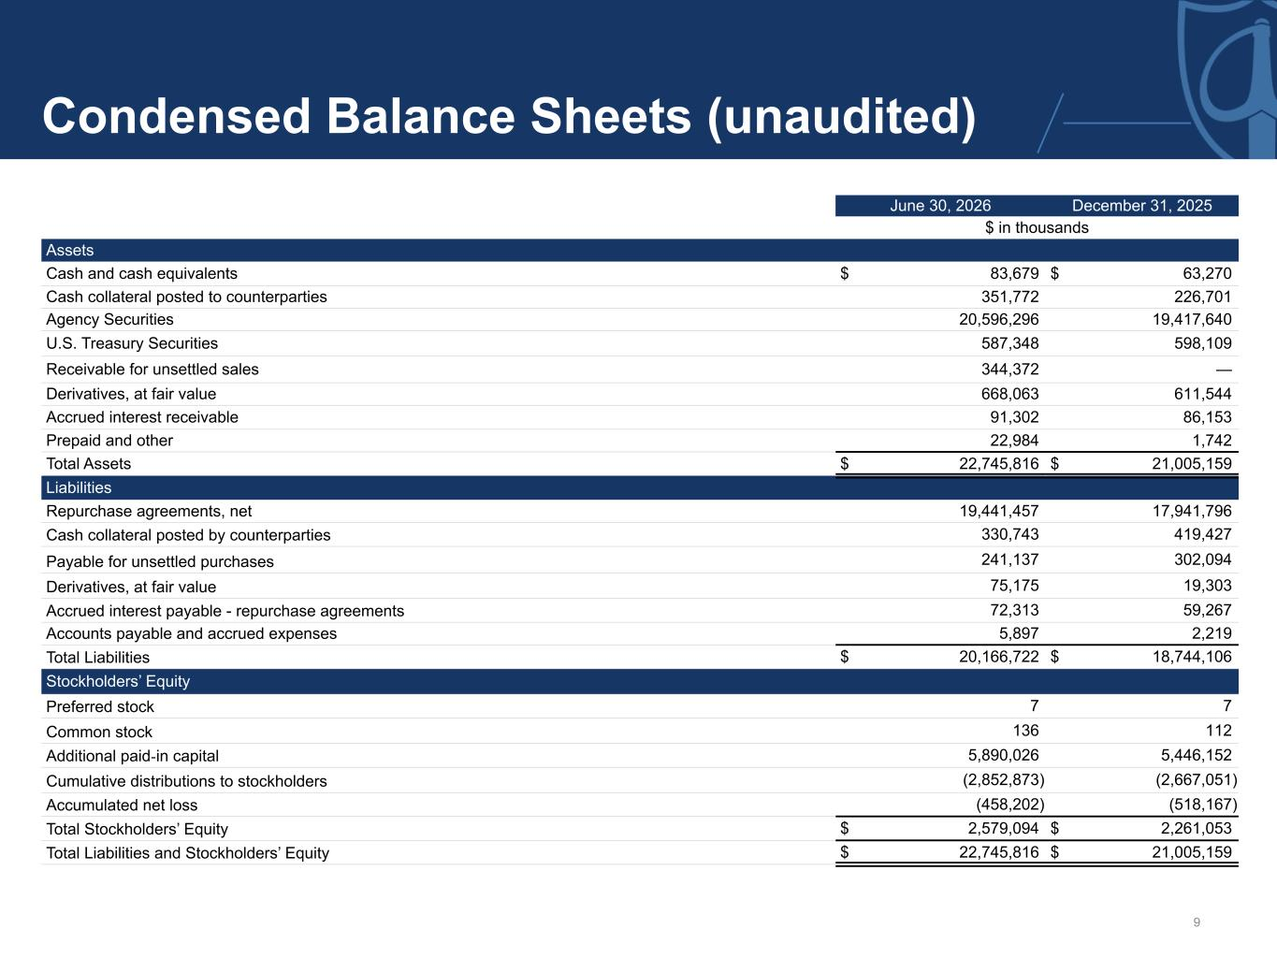
9 Condensed Balance Sheets (unaudited) June 30, 2026 December 31, 2025 $ in thousands Assets Cash and cash equivalents $ 83,679 $ 63,270 Cash collateral posted to counterparties 351,772 226,701 Agency Securities 20,596,296 19,417,640 U.S. Treasury Securities 587,348 598,109 Receivable for unsettled sales 344,372 — Derivatives, at fair value 668,063 611,544 Accrued interest receivable 91,302 86,153 Prepaid and other 22,984 1,742 Total Assets $ 22,745,816 $ 21,005,159 Liabilities Repurchase agreements, net 19,441,457 17,941,796 Cash collateral posted by counterparties 330,743 419,427 Payable for unsettled purchases 241,137 302,094 Derivatives, at fair value 75,175 19,303 Accrued interest payable - repurchase agreements 72,313 59,267 Accounts payable and accrued expenses 5,897 2,219 Total Liabilities $ 20,166,722 $ 18,744,106 Stockholders’ Equity Preferred stock 7 7 Common stock 136 112 Additional paid-in capital 5,890,026 5,446,152 Cumulative distributions to stockholders (2,852,873) (2,667,051) Accumulated net loss (458,202) (518,167) Total Stockholders’ Equity $ 2,579,094 $ 2,261,053 Total Liabilities and Stockholders’ Equity $ 22,745,816 $ 21,005,159

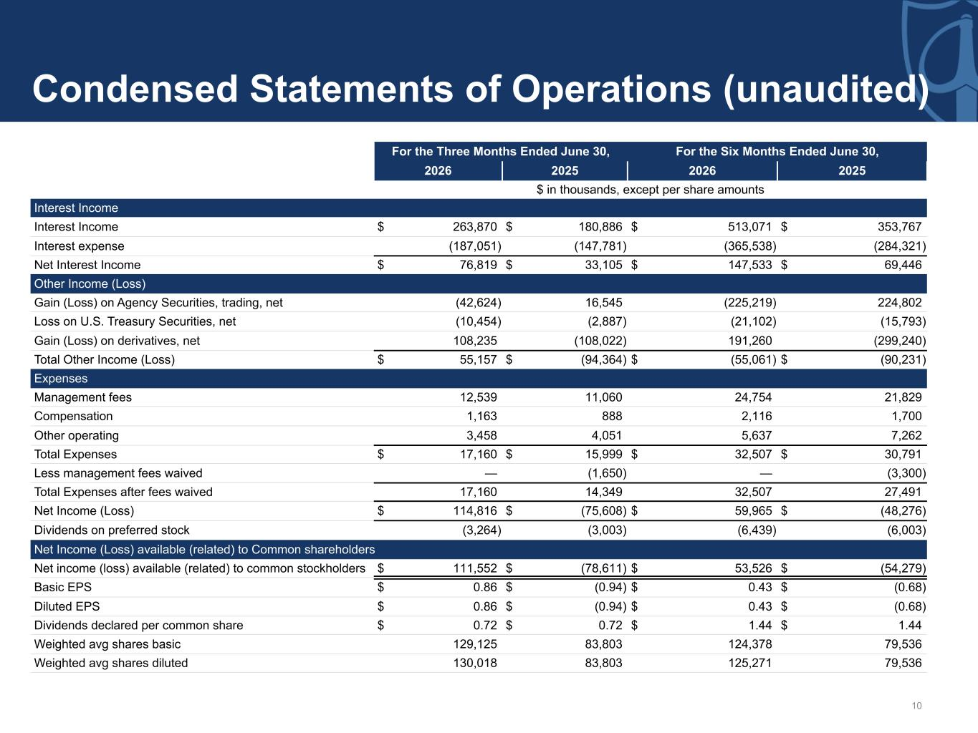
10 Condensed Statements of Operations (unaudited) For the Three Months Ended June 30, For the Six Months Ended June 30, 2026 2025 2026 2025 $ in thousands, except per share amounts Interest Income Interest Income $ 263,870 $ 180,886 $ 513,071 $ 353,767 Interest expense (187,051) (147,781) (365,538) (284,321) Net Interest Income $ 76,819 $ 33,105 $ 147,533 $ 69,446 Other Income (Loss) Gain (Loss) on Agency Securities, trading, net (42,624) 16,545 (225,219) 224,802 Loss on U.S. Treasury Securities, net (10,454) (2,887) (21,102) (15,793) Gain (Loss) on derivatives, net 108,235 (108,022) 191,260 (299,240) Total Other Income (Loss) $ 55,157 $ (94,364) $ (55,061) $ (90,231) Expenses Management fees 12,539 11,060 24,754 21,829 Compensation 1,163 888 2,116 1,700 Other operating 3,458 4,051 5,637 7,262 Total Expenses $ 17,160 $ 15,999 $ 32,507 $ 30,791 Less management fees waived — (1,650) — (3,300) Total Expenses after fees waived 17,160 14,349 32,507 27,491 Net Income (Loss) $ 114,816 $ (75,608) $ 59,965 $ (48,276) Dividends on preferred stock (3,264) (3,003) (6,439) (6,003) Net Income (Loss) available (related) to Common shareholders Net income (loss) available (related) to common stockholders $ 111,552 $ (78,611) $ 53,526 $ (54,279) Basic EPS $ 0.86 $ (0.94) $ 0.43 $ (0.68) Diluted EPS $ 0.86 $ (0.94) $ 0.43 $ (0.68) Dividends declared per common share $ 0.72 $ 0.72 $ 1.44 $ 1.44 Weighted avg shares basic 129,125 83,803 124,378 79,536 Weighted avg shares diluted 130,018 83,803 125,271 79,536

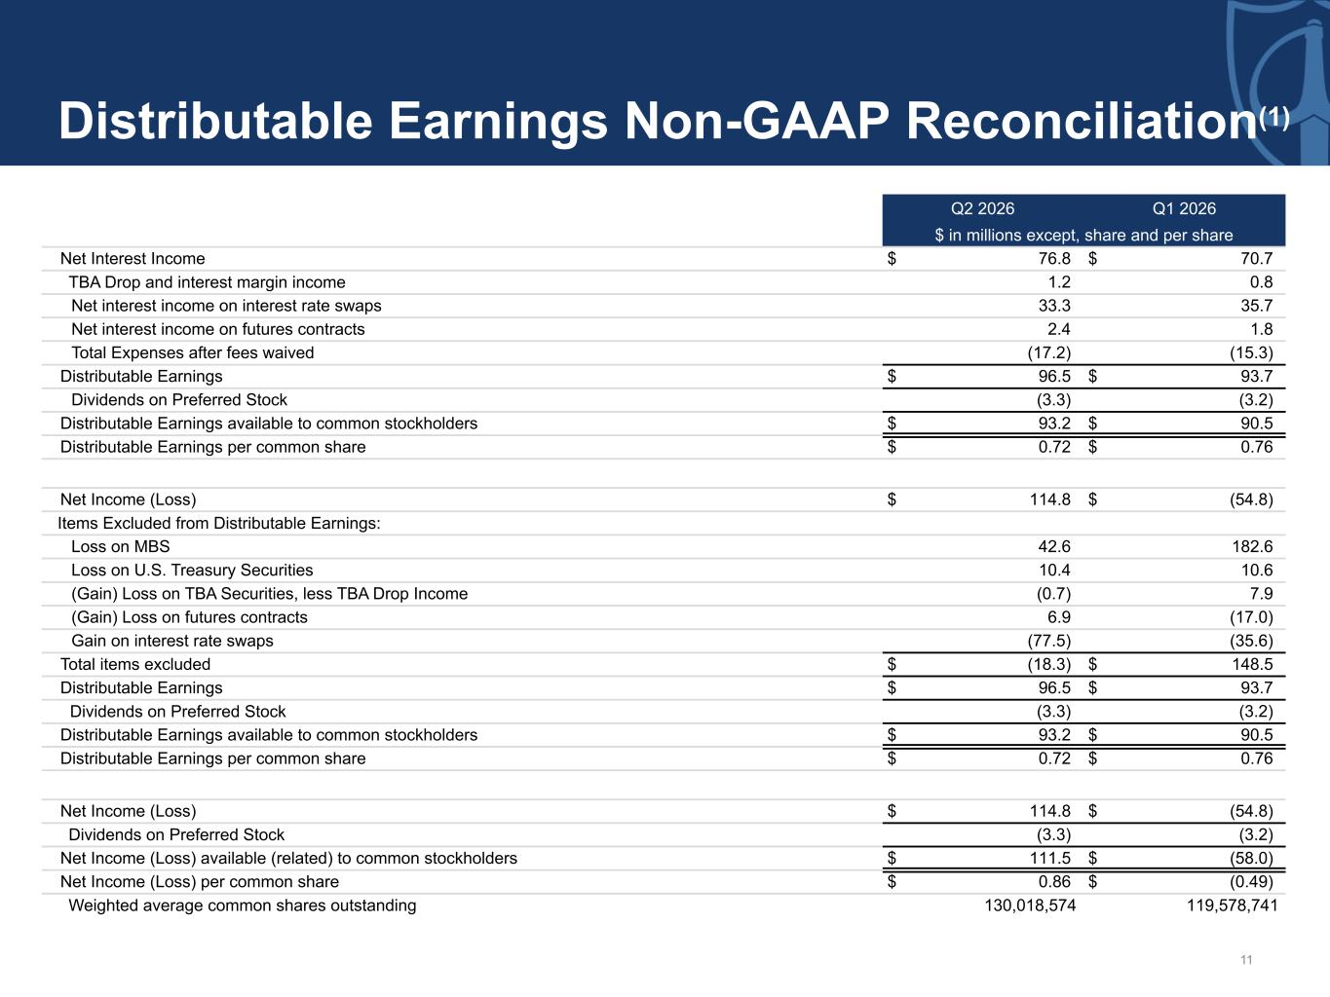
11 Distributable Earnings Non-GAAP Reconciliation(1) Q2 2026 Q1 2026 $ in millions except, share and per share Net Interest Income $ 76.8 $ 70.7 TBA Drop and interest margin income 1.2 0.8 Net interest income on interest rate swaps 33.3 35.7 Net interest income on futures contracts 2.4 1.8 Total Expenses after fees waived (17.2) (15.3) Distributable Earnings $ 96.5 $ 93.7 Dividends on Preferred Stock (3.3) (3.2) Distributable Earnings available to common stockholders $ 93.2 $ 90.5 Distributable Earnings per common share $ 0.72 $ 0.76 Net Income (Loss) $ 114.8 $ (54.8) Items Excluded from Distributable Earnings: Loss on MBS 42.6 182.6 Loss on U.S. Treasury Securities 10.4 10.6 (Gain) Loss on TBA Securities, less TBA Drop Income (0.7) 7.9 (Gain) Loss on futures contracts 6.9 (17.0) Gain on interest rate swaps (77.5) (35.6) Total items excluded $ (18.3) $ 148.5 Distributable Earnings $ 96.5 $ 93.7 Dividends on Preferred Stock (3.3) (3.2) Distributable Earnings available to common stockholders $ 93.2 $ 90.5 Distributable Earnings per common share $ 0.72 $ 0.76 Net Income (Loss) $ 114.8 $ (54.8) Dividends on Preferred Stock (3.3) (3.2) Net Income (Loss) available (related) to common stockholders $ 111.5 $ (58.0) Net Income (Loss) per common share $ 0.86 $ (0.49) Weighted average common shares outstanding 130,018,574 119,578,741

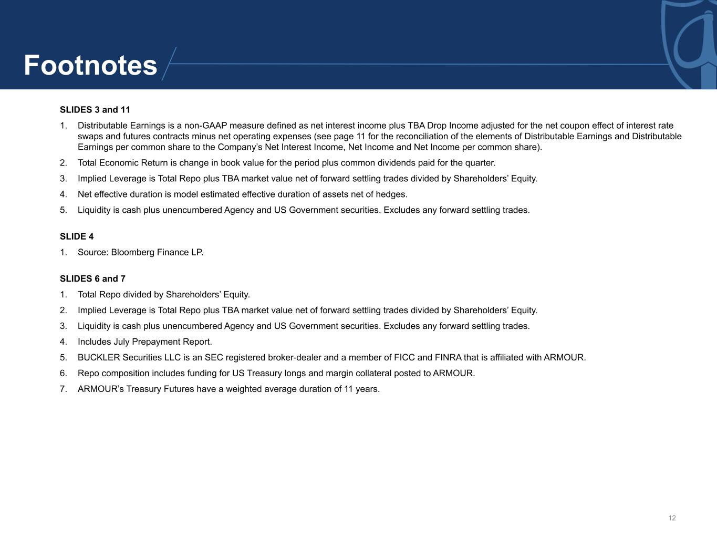
12 SLIDES 3 and 11 1. Distributable Earnings is a non-GAAP measure defined as net interest income plus TBA Drop Income adjusted for the net coupon effect of interest rate swaps and futures contracts minus net operating expenses (see page 11 for the reconciliation of the elements of Distributable Earnings and Distributable Earnings per common share to the Company’s Net Interest Income, Net Income and Net Income per common share). 2. Total Economic Return is change in book value for the period plus common dividends paid for the quarter. 3. Implied Leverage is Total Repo plus TBA market value net of forward settling trades divided by Shareholders’ Equity. 4. Net effective duration is model estimated effective duration of assets net of hedges. 5. Liquidity is cash plus unencumbered Agency and US Government securities. Excludes any forward settling trades. SLIDE 4 1. Source: Bloomberg Finance LP. SLIDES 6 and 7 1. Total Repo divided by Shareholders’ Equity. 2. Implied Leverage is Total Repo plus TBA market value net of forward settling trades divided by Shareholders’ Equity. 3. Liquidity is cash plus unencumbered Agency and US Government securities. Excludes any forward settling trades. 4. Includes July Prepayment Report. 5. BUCKLER Securities LLC is an SEC registered broker-dealer and a member of FICC and FINRA that is affiliated with ARMOUR. 6. Repo composition includes funding for US Treasury longs and margin collateral posted to ARMOUR. 7. ARMOUR’s Treasury Futures have a weighted average duration of 11 years. Footnotes

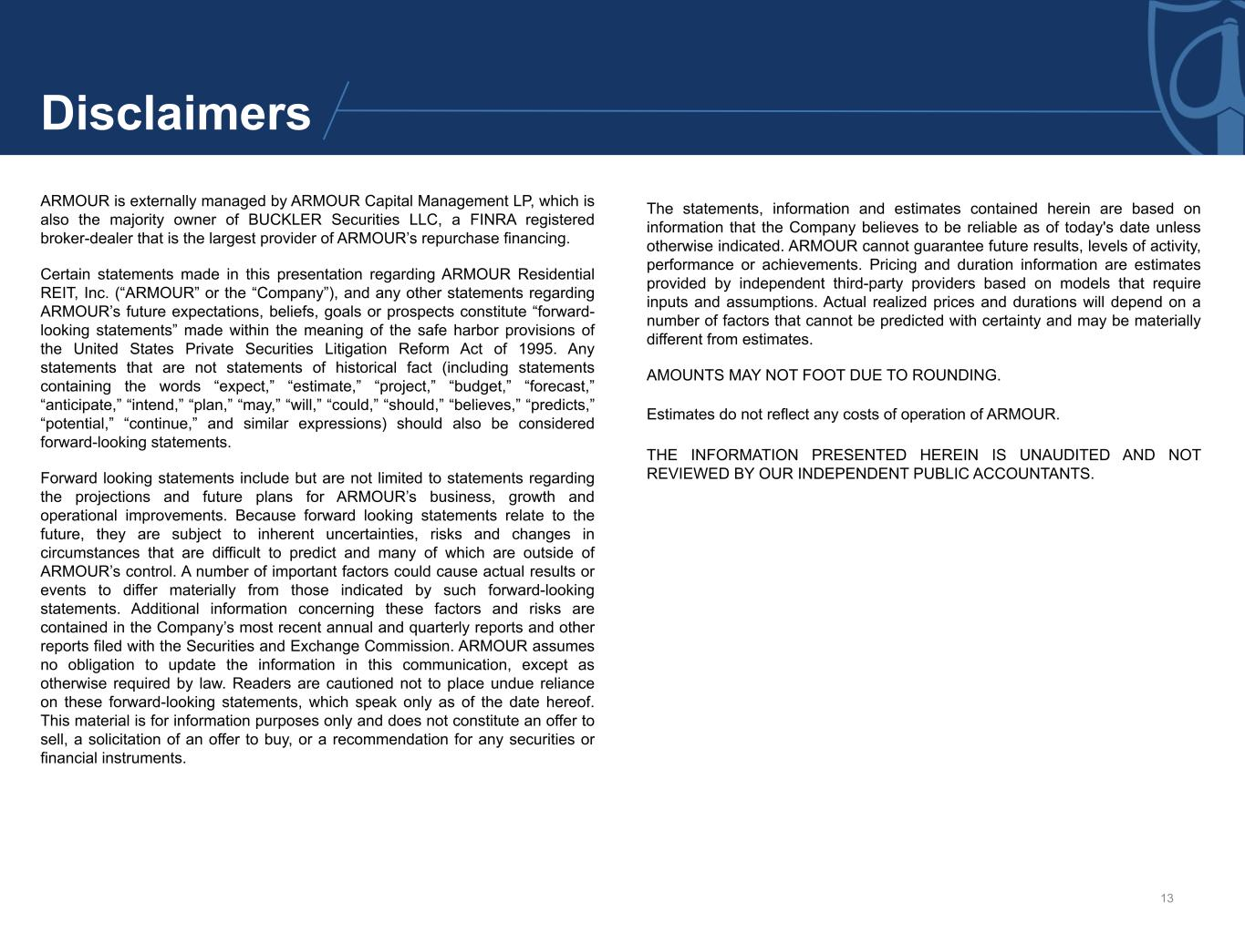
13 ARMOUR is externally managed by ARMOUR Capital Management LP, which is also the majority owner of BUCKLER Securities LLC, a FINRA registered broker-dealer that is the largest provider of ARMOUR’s repurchase financing. Certain statements made in this presentation regarding ARMOUR Residential REIT, Inc. (“ARMOUR” or the “Company”), and any other statements regarding ARMOUR’s future expectations, beliefs, goals or prospects constitute “forward- looking statements” made within the meaning of the safe harbor provisions of the United States Private Securities Litigation Reform Act of 1995. Any statements that are not statements of historical fact (including statements containing the words “expect,” “estimate,” “project,” “budget,” “forecast,” “anticipate,” “intend,” “plan,” “may,” “will,” “could,” “should,” “believes,” “predicts,” “potential,” “continue,” and similar expressions) should also be considered forward-looking statements. Forward looking statements include but are not limited to statements regarding the projections and future plans for ARMOUR’s business, growth and operational improvements. Because forward looking statements relate to the future, they are subject to inherent uncertainties, risks and changes in circumstances that are difficult to predict and many of which are outside of ARMOUR’s control. A number of important factors could cause actual results or events to differ materially from those indicated by such forward-looking statements. Additional information concerning these factors and risks are contained in the Company’s most recent annual and quarterly reports and other reports filed with the Securities and Exchange Commission. ARMOUR assumes no obligation to update the information in this communication, except as otherwise required by law. Readers are cautioned not to place undue reliance on these forward-looking statements, which speak only as of the date hereof. This material is for information purposes only and does not constitute an offer to sell, a solicitation of an offer to buy, or a recommendation for any securities or financial instruments. The statements, information and estimates contained herein are based on information that the Company believes to be reliable as of today's date unless otherwise indicated. ARMOUR cannot guarantee future results, levels of activity, performance or achievements. Pricing and duration information are estimates provided by independent third-party providers based on models that require inputs and assumptions. Actual realized prices and durations will depend on a number of factors that cannot be predicted with certainty and may be materially different from estimates. AMOUNTS MAY NOT FOOT DUE TO ROUNDING. Estimates do not reflect any costs of operation of ARMOUR. THE INFORMATION PRESENTED HEREIN IS UNAUDITED AND NOT REVIEWED BY OUR INDEPENDENT PUBLIC ACCOUNTANTS. Disclaimers

